**Sign In:**

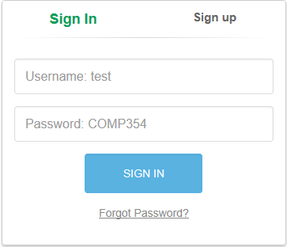

Here where you can sign in to your existing account; Username and Password are required to sign in to your account. Moreover, you can hit the “Forgot Password?” if you don’t remember your password, otherwise just hit the “SIGN IN” button and enjoy the game!

**Sign up:**

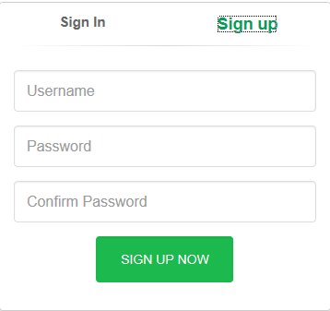

If it is your first time here, i.e. you don’t have an account yet, then you can easily pick a username and a password and press “SIGN IN NOW” to get into the game!

**The Playing Field:**

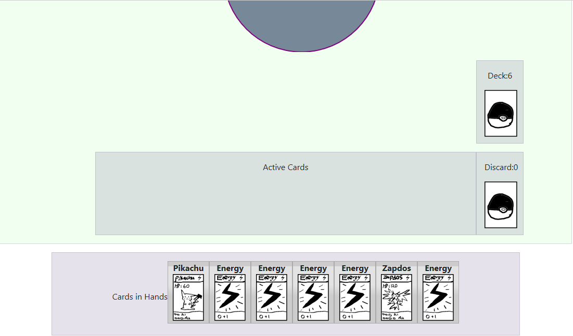

Two similar parts are exist actually for the playing field: the lower part (your field) and the upper part (your opponent’s field), and they both have same look and same sub-parts (each is shown below).

**The Deck:**

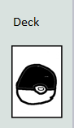

Here where you draw and search for cards (initially, there is 60 cards in the Deck). You’ll use the deck to draw 7 initial cards, and then 1 new card every turn.

**The Discard Pile:**

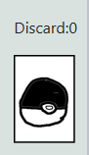

This is where used trainer cards go when you are done, as well as knocked out Pokémon and their depending energies.

**Cards in Hands:**

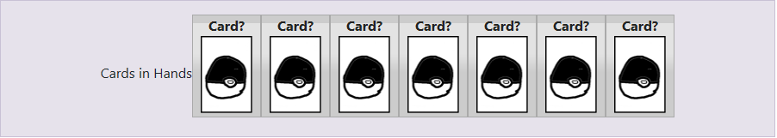

This is where you keep your available cards to play (should be kept hidden from you opponent 😉 ); You will put cards here every time you draw from the deck.

**Active Cards:**



This is where you put your Pokémon (and possibly its Energies) to attack; knowing that the active Pokémon is the only Pokémon that can attack.

An example of a field with one active Pokémon:

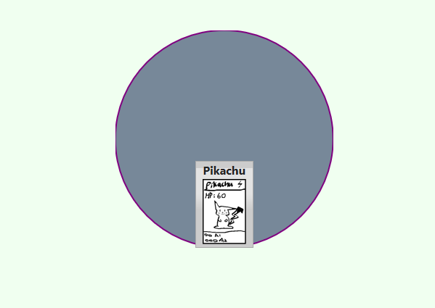

**The Bench:**



It can hold up to five Pokémon at a time (in addition for your Active Pokémon); you can choose your Pokémon to put in the Bench from the cards you have already in hand, and they are the only Pokémon that a player can put in or switch with the active card.

An example with a Bench with 2 Pokemon cards:



**Prizes Cards:**

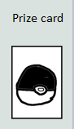

At the start of each game, some cards from the Deck are placed facedown in the side (usually six cards), they are the prizes cards! Getting a knockout lets you take a prize card and put it in your hand, and taking all six prizes wins you the game 😉.

**Taskbar:**



In the taskbar, you may choose between these options:

1. Start a New Game; allows you to start a new game in the playing field.
2. Update collection; allows you to upload some cards collection, and here is how it looks like when go for it:

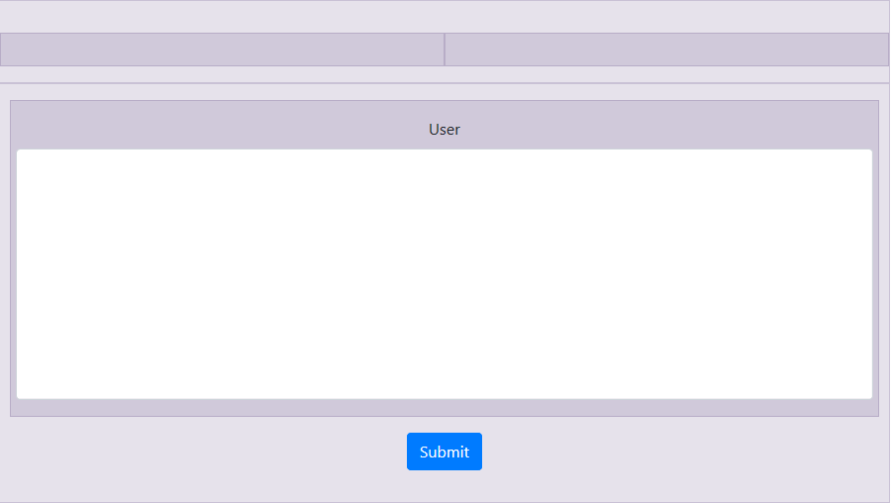

1. Update Deck; simply updating decks for User and AI. Here how it looks like:

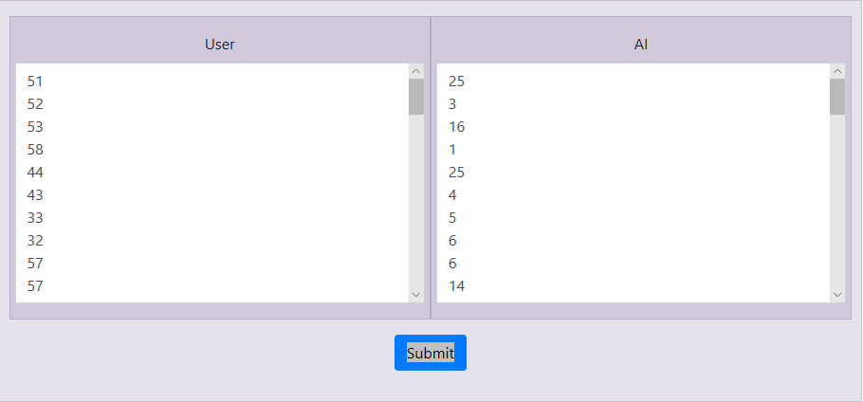

1. Logout; to logout from your account, then it takes you to the sign in page again!